**Image Album App**

March 21, 2016

Ante Hakstok

Antonio Labriola

Marko Pancirov

Ana Hakstok

**Class table and description**

ImageAlbum: The main method will be in this class, it uses all other classes.

Image: represents the image, stores data about the image

Album: A collection of Image objects, can add and delete images from that collection. aggregates Image objects

ImageEditor: manipulates images. Stores a reference of the image being edited.

**Class diagram**

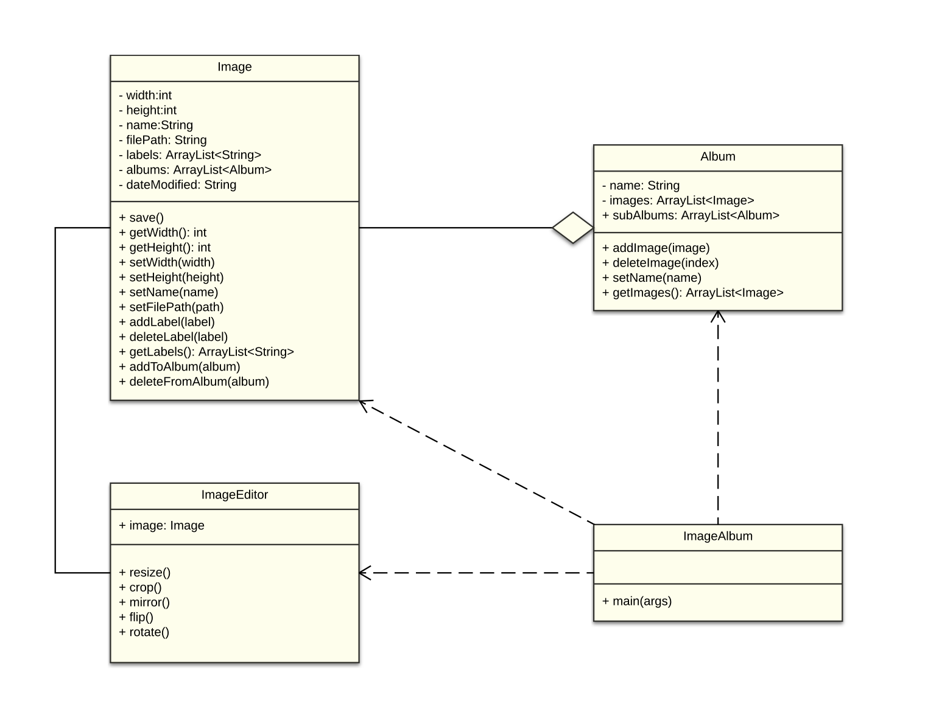

**Sequence Diagram**

